IT2654 Systems Administration & Security

Tutorial 12

- (a) What are the different ways to configure the Linux firewall?

system-config-firewall
system-config-firewall-tui
iptables (CLI)
Edit /etc/sysconfig/iptables file
- When the firewall is enabled via system-config-firewall, what default rules are put into place:
Accept everything (chain input and output)

- (a) Describe the architecture of the Linux firewall.

It is made up of 5 tables. Each table consists of chains which are collections of rules. Each rule can have multiple criteria but one target.

We only use filter.

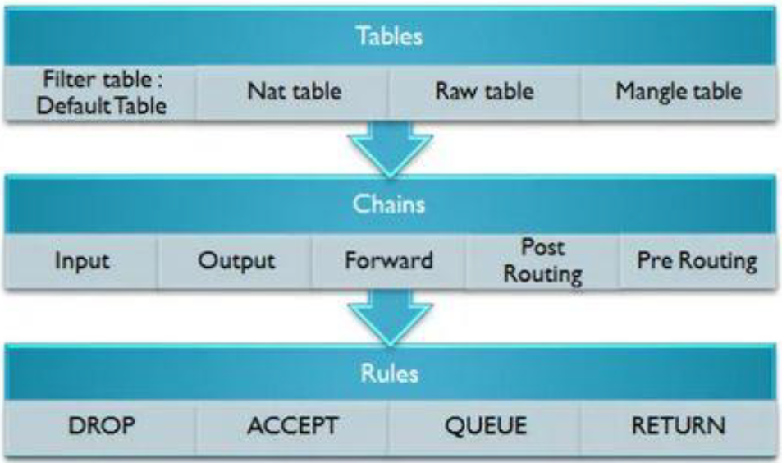

- Where does filtering occur when using netfilter?
Occurs in all the chains (input, output, forward, post routing, pre routing)

- (a) Describe the rule below in terms of table, criteria and target.
iptables –t filter –A INPUT –s 192.168.10.1 –j DROP

-t = table (optional)
table = filter
chain = input
-A = append
target = drop

If source IP address is 192.168.10.1, the packet is dropped

(b) What happens if none of the rules are matched?
The chain policy will apply

- (a) Can netfilter do content filtering?
No.

(b) What is a target? List some of its values and their meaning.
Target – a rule that is matched to a target. A target decides the fate of a packet, such as allowing or rejecting it.

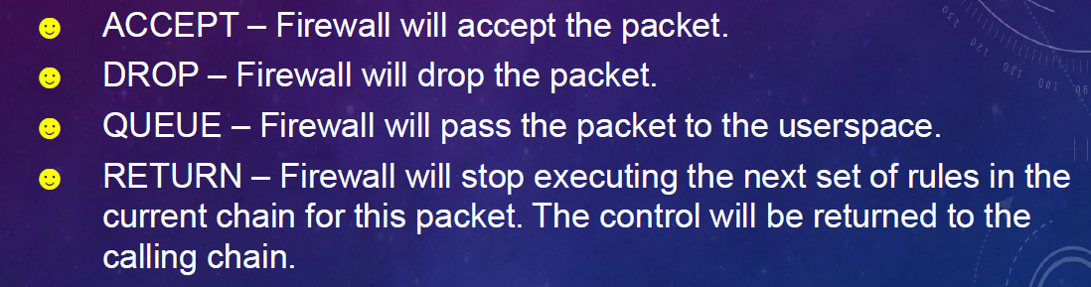
- Packet filtering takes place within the kernel at the five packet filtering points known as Built-in Chains. List the 5 built-in chains and describe their functions.

  - INPUT Chain
    - This filtering point handles packets destined for the local system, after the routing decision. INPUT Chain is present in the mangle and filter tables. Only packets terminating on localhost traverse this chain.
  - PREROUTING Chain
    - This filtering point deals with packets first upon arrival (conntrack , mangle, nat). PREROUTING Chain is present in the conntrack , nat and mangle tables. Packets traverse this chain before a routing decision is made by the kernel.
  - FORWARD Chain
    - This filtering point handles packets being routed through the local system (mangle, filter). FORWARD Chain is present in the mangle and filter tables. Only packets that neither originate nor terminate at the local host traverse this chain.
  - OUTPUT Chain
    - This filtering point handles packets after they have left their sending process and prior to POSTROUTING conntrack , mangle, nat ,filter). OUTPUT Chain is present in the conntrack , nat , mangle and filter tables. Only packets originating on localhost traverse this chain.
  - POSTROUTING Chain
    - This filtering point handles packets immediately prior to leaving the system (mangle, nat). POSTROUTING Chain is present in the nat and mangle tables. Packets traverse this chain after a routing decision is made by the kernel.

We only focus on input chain, output chain and forward chain.

- What is the rule-matching features in netfilter that an administrator needs to understand before creating rules?
- Rules are in ordered list
- Packets tested against each rule in turn
- If the criteria are matched, it goes to the rules specified in the target (or) executes the special values mentioned in the target
- If the criteria are not matched, it moves on to the next rule
- Rule may specify multiple criteria for match
- Every criterion in a specification must be met for the rule to match (logical AND)
- Chain policy applies if no match

